**Assignment 01**

Submitted By: Aagnay Kariyal

Student ID: 8830232

# **Problem 01**

Problem Definition

States

Actions

Rewards

# **Problem 02**

# **Problem 03**

Initializing all the values and importing all the dependencies

Calculating the max value:

Performing the calculation by calling the gridworld class:

Updating values:

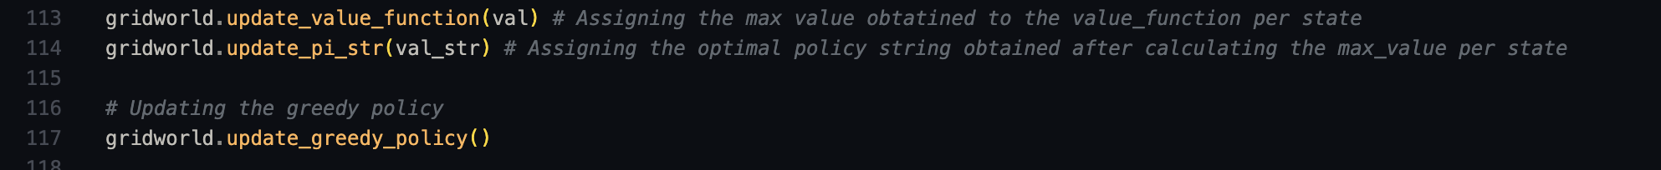

Printing out the results:

Results:

Optimal Value Function:

Optimal Policy:

